Final Project: Pick a Project
Computer Science - Week 10
Oct 3, 2026 - Version 0.0.2
Please make sure to your UD email AND name is below. Unless your UD emails are included in this table, then you will not earn any points for this assignment when it is graded! Every person should submit their own individual worksheet.

Talk about each of the questions with a friend or our LLM (or both), but make sure the words you enter below are yours (with the obvious exceptions notwithstanding). Brainstorming is best done in full sentences, and the main goal here is brainstorming. It's worth reviewing the information in this series of pages in the Drafter documentation to gain a better understanding of the process.

Role | Name | Email
Developer (You) | Sydney Whittaker | swhitt@udel.edu
Friend (optional) | Kira Fidgeon

Part 1: The Goal & Prior Implementations
- Identify the Goal: What specific goal are you trying to address? Think about your passions, hobbies, and academic interests. The latter are an excellent candidate to focus on. Some majors have suggestions listed below: these were provided by faculty in those departments. Other majors could consider a focus tied to a big final assignment in one of their recent courses in their major.
  - Biomedical Engineering majors may consider one of the following:
    - If you have started (or completed) the Cell/Tissue Design final project in BMEG100, design an organoid, which involves combining a cell type, biomaterial, and testing method. Have the website include a description and diagram of your design concept, a testing method, a needs statement, and an impact statement relevant to their organoid. Also include a link to a paper that supports your idea and a paragraph describing how that paper supports your design concept.
    - Otherwise, create a website related to your BMEG100 Lab Report 1, Cytoskeletal and Nuclear Staining Lab Report Guidelines, linked here (University of Delaware account required to access).
  - Chemistry and Chemical Engineering majors may consider creating an automated chemistry assistant that takes balanced reaction equations, starting reactant masses, and a harvested product amount to determine the limiting reactant, theoretical yield, and percent yield based on principles from Chemistry 2e (OpenStax) — Chapter 4: Chemical Reactions and Stoichiometry. To avoid manually compiling atomic mass tables or writing custom string tokenizers, use the ChemPy library to parse molecular formulas into exact molecular weights and verify reaction stoichiometry against compound data from the NIH PubChem Database. The program outputs an organized breakdown of limiting reagent status, product yields, and remaining masses of unreacted species. Also use the heat of the reaction to determine if it is exothermic or endothermic, and compute the heat flow per mole of the product.
  - Majors in the Electric & Computer Engineering department may consider a steganography project that hides messages in images, and then retrieves those messages from uploaded images.
  - Mechanical Engineering majors may consider a project that somehow uses both the NumPy and SciPy Python libraries.
Rocket Trajectory Estimator

- Prior Implementations: Search the internet. What existing tools or websites currently attempt to address it?
Existing tools include rocket flight simulators and trajectory calculators that estimate how a rocket or object moves based on variables such as velocity, altitude, and launch angle. An example is PhysicsLearn's Projectile Motion Simulator, which displays the object's path.

- Your Implementation: Briefly describe the legitimate purpose or functionality of your site. How would you want this web application to be used?
The user would enter the rocket's initial velocity, starting height, and launch angle into the website. The application would then use physics equations to estimate the rocket's trajectory, maximum height, and distance traveled, then portray it in a graph. The goal is to help users understand projectile motion and explore how changing variables can drastically affect the rocket's path. The website will be an educational or fun endeavor, not to be used with real spaceships.

Part 2: The Input-Process-Output (IPO) Model
Think about the fundamental flow of your program.
- The Core Goal: Every program has three main phases: taking input, processing data, and presenting output. In one sentence, what is the ultimate goal your program will accomplish for the user? Be specific and use CS1 concepts.
The goal of this program is for the user to input information about a rocket or another object, process the data using physics and calculus formulas, and output the predicted trajectory and calculated values of the object’s motion.

- Input: What specific information will the user need to provide to your program? (e.g., a city name, a numerical budget, a list of hobbies).
The user must input the object’s initial velocity and launch angle. The program will use these numerical values to predict the object’s motion after its launch.

- Processing: At a high level, how will the computer manipulate or evaluate that data? (e.g., calculate the average, filter out options that are too expensive, compare the input against a database).
The program will store the user’s inputs in variables and use known physics and calculus formulas to calculate the object’s maximum height, total flight time, and horizontal distance traveled. It will assume that air resistance is ignored and that the object lands at the same height from which it was launched.

- Output: What will the user get back? (e.g., a recommendation, a calculated safety factor, a formatted schedule).
The program will display the predicted trajectory of the object along with its calculated maximum height, total flight time, and horizontal distance. The results will be presented in a clear format so users can understand how changing the initial velocity or launch angle affects the object’s motion.

Part 3: Data Abstraction
Identify the "nouns" of your problem.
- Representing Reality: Abstraction is the process of representing the real world inside a computer by ignoring unnecessary details. What are the core "things" (nouns) your program needs to track? (e.g., If building a recipe app, the nouns are "Recipe" and "Ingredient").
The core needs of my program are the object or rocket, initial velocity, launch angle, desired path, maximum height, flight time, and horizontal distance.

- Identifying Properties: For the most important "thing" you listed above, what 3 to 4 specific details do you actually need to solve your problem, and what details will you abstract away?
  - Details I need: (e.g., Ingredient name, weight, cost)
  - Details I will ignore: (e.g., Ingredient color, brand, expiration date)
The details I need are initial velocity, launch angle, starting height, and gravity. The details I will ignore are the object's color, shape, material, actual appearance, and mass. They are unnecessary because the computer will assume there is no air resistance.

Part 4: Challenges, AI Strategy, & Goals
- Difficulties: What parts of this project seem the most difficult or technically complex?
The parts of this project that seem the most difficult are finding exactly how to make the program understand what I am asking of it, and how to implement the known formulas for it to use.

- Coding Strategy: If you will be using an LLM to help code, how will you ensure you understand the generated code and avoid "hallucinations" or "shallow learning" (copying without understanding)? If you won't be using an LLM to help code, this project might take about 4 hours a week to complete, so list each of the days and times in which you work on the project.
I will avoid this by asking the LLM to explain the code it has given me and review each line.

- Goals: What is your ultimate goal for this project? (e.g., Impress the graders with a creative UI, build something I can use in my other classes, learn Drafter deeply).
My ultimate goal for this project is to create an interesting and immersive website that makes people want to learn more.

Part 5: Research & Brainstorming Conversation
Have a conversation with a Generative AI tool (like ChatGPT or Claude) OR a friend about your project idea. Do not ask for code. Instead, use the AI/friend as a sounding board to research your problem.
- The Initial Prompt/Question: Ask the AI or your friend to help you brainstorm. (e.g., "I want to build a simple web tool to help students track their study hours. What are 3 common problems students face when tracking their time, and what are 3 simple features a basic tool should have?"). Paste your prompt below:
I would like to build a website to allow people to estimate the trajectory of an object or rocket. What are 3 common problems that could be found in this field, and what should I ensure I add? Also, what are existing solutions or prior apps to look at?

- The Response: Briefly summarize the best ideas the AI or your friend suggested. What existing solutions or prior apps did they mention?
The AI suggested using PhET as my main inspiration, but ensure that I keep my calculations simple so that I am able to complete them using my CS1 Python skills. It also suggests describing my project as an ideal projectile-motion estimator rather than a real-world rocket launch predictor because rockets require more complicated physics. Some existing solutions or prior apps that it mentions were PhET Projectile Motion, The Physics Classroom Projectile Simulator, and Pearson Projectile Motion Calculator.

- The Pushback: You must reply to the AI/friend to narrow the scope when it's over-ambitious. Pick the most complex feature they suggested and explain why it is too complicated for an introductory programming project. Ask them for a simpler alternative. Paste your response here:
"Include a 2D graph that displays the object's curved trajectory. Allow users to change the launch angle and velocity to see how the path changes." I am not quite sure how to do this yet; could you make a simpler alternative, but still include a graph?

- Reflection: Based on this conversation, how has your project idea changed or become more focused?
My project idea has become more focused by listening to the AI explain exactly what I should and should not include. I have learned how it will be difficult to program everything I wanted at first, but there are ways to make it simpler and still retain the same idea.

Part 6: Resource Planning
- What resources will you use if you get stuck?
The resources I will use if I get stuck include my chosen LLM, office hours, my classmates, and other websites such as PhET as examples.

- If your LLM provides code that causes a Drafter or Bakery error, or if you run into a problem during deployment, what is your step-by-step debugging plan to resolve it?
I will first read the error message to find exactly what the problem is. Then, I will check all of my variable names, function definitions, and calculations for mistakes. I will insert print functions and test each individual function to make sure they work correctly. If I still have problems, I will ask a classmate, my LLM, or research the type of error I was given. Lastly, I will run my program again.

Part 7: LLM Conversation
If you used an LLM in any part of this work, copy and paste every part of that conversation below. Otherwise, you may be given a zero for the assignment. Obviously, these words will not all be yours, and this is the exception to the requirement at the top of this assignment that all responses be in your own words. If you did not use an LLM to assist you in this assignment, simply say so below.
Can you please give me all of the inputs and outputs I will need for this program?
For your Rocket Trajectory Estimator, I recommend keeping the inputs and outputs simple enough for a CS1 Python/Drafter project while still including all the information needed to calculate and graph projectile motion.

1. Inputs
These are the values the user will enter into your website.
Input | Description | Example
Initial velocity | The starting speed of the object (m/s). | 30
Launch angle | The angle at which the object is launched (degrees). | 45
Starting height | The height from which the object is launched (meters). | 0
You could also include a Calculate Trajectory button to submit the values.

2. Processing
Your program will take the inputs and use physics formulas to calculate the following:
Calculation | Description
Horizontal velocity | How fast the object moves horizontally.
Vertical velocity | How fast the object moves upward.
Maximum height | The highest point the object reaches.
Total flight time | How long the object stays in the air.
Horizontal distance | How far the object travels before landing.
Trajectory coordinates | A collection of horizontal and vertical positions used to create the graph.

3. Outputs
These are the results your website will display to the user.
Output | Description
Maximum height | Displays the highest point reached (meters).
Total flight time | Displays how long the object remains in the air (seconds).
Horizontal distance | Displays the total distance traveled (meters).
Velocity information | Displays the horizontal and vertical velocity components (m/s).
Trajectory graph | Displays a 2D curved graph showing the object's predicted flight path.

4. Example of what your website could display

Rocket Trajectory Estimator
EXAMPLE CALCULATION
Initial velocity
30 m/s
Launch angle
45°
Starting height
0 m
Gravity
9.8 m/s²
Calculated results

22.96 m
Maximum height

4.33 s
Total flight time

91.84 m
Horizontal distance

21.21 m/s
Horizontal velocity
Predicted trajectory
Add More
Illustrative example using a 30 m/s launch speed, a 45° angle, and a starting height of 0 m.

5. Important assumptions
To keep your calculations manageable, I recommend using these assumptions:
- Gravity is constant at 9.8 m/s².
- Air resistance is ignored.
- The object launches and lands at the same height for your initial version.
- The object follows a predictable parabolic path.
One important programming suggestion: You don't need to ask the user to enter gravity. You can store 9.8 as a constant in your Python program instead.
This gives you three user inputs, several calculations, and a graph without making the project unnecessarily complicated.
I would like to build a website to allow people to estimate the trajectory of an object or rocket. What are 3 common problems that could be found in this field, and what should I ensure I add? Also, what are existing solutions or prior apps to look at?
For your Rocket Trajectory Estimator, I would focus on problems that make it difficult for people to predict an object's movement, understand the calculations, or visualize its path. You can use existing projectile-motion calculators as examples when deciding what features to include.

1. Three common problems and features to include
Problem 1: Understanding complicated physics calculations
- Problem: People may struggle with physics formulas involving initial velocity, launch angles, gravity, and acceleration.
- What to add: Include input boxes where users can enter their initial velocity and launch angle. Automatically calculate maximum height, total flight time, and horizontal distance.
Problem 2: Inaccurate or unrealistic predictions
- Problem: Basic trajectory calculators often simplify real-world conditions. Users may assume the results perfectly represent how an actual rocket or object will move.
- What to add: Clearly explain the assumptions behind the calculations, such as constant gravity and no air resistance. You could also allow users to enter a different starting height.
Problem 3: Difficulty visualizing the trajectory
- Problem: Seeing numerical results alone makes it difficult to understand the actual path an object follows.
- What to add: Include a 2D graph that displays the object's curved trajectory. Allow users to change the launch angle and velocity to see how the path changes.

2. Existing solutions and prior apps to research
Here are three existing tools that are worth looking at for your project.
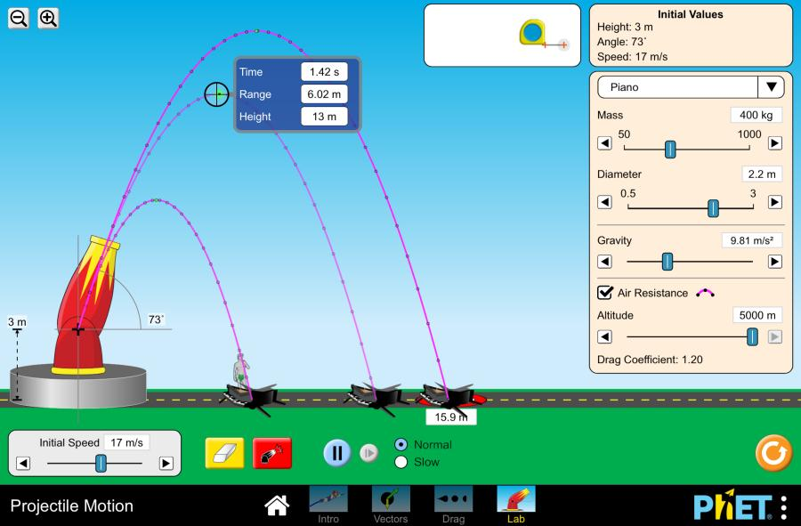
1. PhET Projectile Motion
Visit PhET
- Allows users to launch different objects.
- Change initial speed, launch angle, and mass.
- Experiment with air resistance.
- Shows how changing variables affects the trajectory.
Best example for interactive simulations.
PhET Simulations
+1
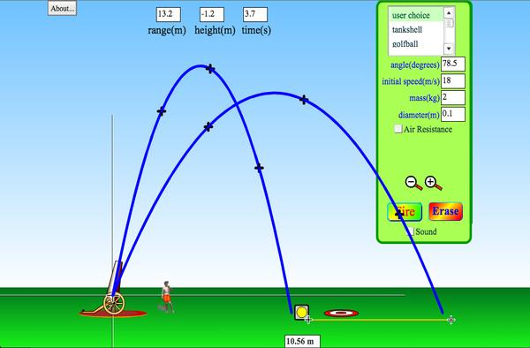
2. The Physics Classroom Projectile Simulator
Visit Physics Classroom
- Allows users to adjust launch speed, height, and angle.
- Displays trajectory, range, and flight time.
- Includes velocity and acceleration vectors.
Best example for displaying calculated results.
Physics Classroom
+1
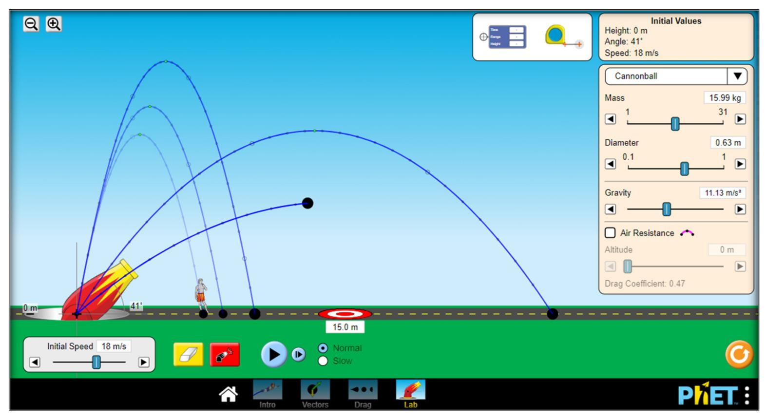
3. Pearson Projectile Motion Calculator
Visit Pearson Calculator
- Calculates maximum height, range, and flight time.
- Allows users to select different units.
- Includes options to solve for launch speed or angle.
- Provides a small trajectory visualization.
Best example for a straightforward calculation website.
Pearson

3. What I would ensure your website includes
For your introductory programming project, I recommend these features:
Feature | Purpose
Initial velocity input | Allows users to enter launch speed.
Launch angle input | Determines the direction of the launch.
Maximum height calculation | Predicts how high the object will travel.
Flight time calculation | Estimates how long the object stays in the air.
Horizontal distance calculation | Predicts how far the object travels.
2D trajectory graph | Helps users visualize the predicted path.

4. Ready-to-use research summary for your assignment
You could use this for your Prior Implementations section:
There are several existing websites and applications that help users calculate or visualize projectile motion. Examples include PhET Projectile Motion, The Physics Classroom Projectile Simulator, and Pearson's Projectile Motion Calculator. These programs allow users to enter or adjust variables such as initial velocity, launch angle, and starting height to predict an object's movement. Some also include interactive graphs, animations, and calculations for maximum height, flight time, and horizontal distance. I would like to use these existing programs as inspiration while creating a simpler website that focuses on the main calculations and provides an easy-to-understand visual representation of an object's trajectory.
My biggest recommendation: Use PhET as your main inspiration for the interactive experience, but keep your actual calculations and features simple enough to complete with your CS1 Python skills. Also, describe your project as an ideal projectile-motion estimator rather than a real-world rocket launch predictor, since actual rockets require much more complicated physics.
"Include a 2D graph that displays the object's curved trajectory. Allow users to change the launch angle and velocity to see how the path changes." I am not quite sure how to do this yet; could you make a simpler alternative, but still include a graph?
Yes! I would keep the graph but make it much simpler. Instead of creating an interactive graph that changes every time the user adjusts the launch angle and velocity, you could have the program display a basic graph showing the object's predicted trajectory based on the user's inputs.
Simpler alternative:
"Include a basic 2D graph that displays the predicted trajectory of the object using the user's initial velocity and launch angle. The graph will provide a visual representation of the object's movement without requiring complicated animations or interactive features."
How this would work:
- The user enters an initial velocity and launch angle.
- The program calculates the object's maximum height and horizontal distance.
- The program displays those results.
- A basic graph shows the object's curved flight path.
Example of what the graph could look like
Add More
Illustrative trajectory only. Your actual graph would be based on the user's calculations.
This would still make your website visually interesting while keeping the programming manageable for a CS1 project. You could use a simple graphing library rather than having to program an animation yourself.

Part 8: Submit
In Google docs, with this document open, please click on File > Download > Microsoft Word (.docx), and make sure you put that download somewhere you can find it again. Then, upload it to the Canvas assignment about selecting or brainstorming your final project.

When you're done with this assignment, review this page of the Drafter documentation to better prepare for the next step.

